Cache County Firework Restrictions 2026
Amalga: No Firework Restrictions.
Cache County: All areas unincorporated.
Clarkston: No Firework Restrictions. Cornish: All areas within Cornish city limits. Hyde Park: All areas East of 400 East.
Hyrum: No Firework Restrictions.
Lewiston: All areas East of 800 East and all areas West of 2400 West.
Logan: Restrictions below East Bench Closure
- East side of 1600 East from the North City boundary to Hwy 89
- South side of Hwy 89 and South side of the Boulevard Street, from 1600 East to 200 East, then the North side of Canyon Road from 200 East to Crockett Avenue
- East side of Crockett Avenue from Canyon Road to Riverside Drive, continuing the East side of Riverside Drive to Mountain Road, continuing the East side of the Logan River to Stewart Nature Park.
- The North and East side of the Logan City boundary from Stewart Nature Park to the southern city boundary.
West Closure
- West side of 600 West from the North City boundary to 200 South.
- North side of 200 South from 600 West to 1000 West
- West side of 1000 West from 200 South to the South City boundary

Mendon: No Firework Restrictions. Millville: All areas East of 550 East. Newton: No Firework Restrictions.
Nibley: All areas East of Highway 165. North Logan: All areas East of 1600 East. Paradise: No firework Restrictions.
Providence: All areas east of 300 East from 450 North to 100 South and continuing from 100 South to 500 South along Main Street. Restrictions continue for areas south of 500 South and west of Garden Drive to Golf Course road. Areas north of Golf Course Road and Spring Creek Parkway are also restricted. Fireworks are also prohibited in any mountainous, bush-covered, or forested areas; and any underdeveloped wildland or land being used for agricultural purposes.
Richmond: All areas East of 300 East and North of 500 North. River Heights: All areas east of 1000 East.
Smithfield: All areas North of Center Street and East of 200 East. All areas South of Center Street and
East of 800 East.
Trenton: No firework restrictions.
Wellsville: All areas West of 200 West and South of 900 South.

See map on other side.

Cache County Firework Restriction Areas 2026

200
61

23

142

142

91

218

23

252
91
30 89

23

Legend
Highways
Firework Restriction Area
City Boundaries

91

101
165

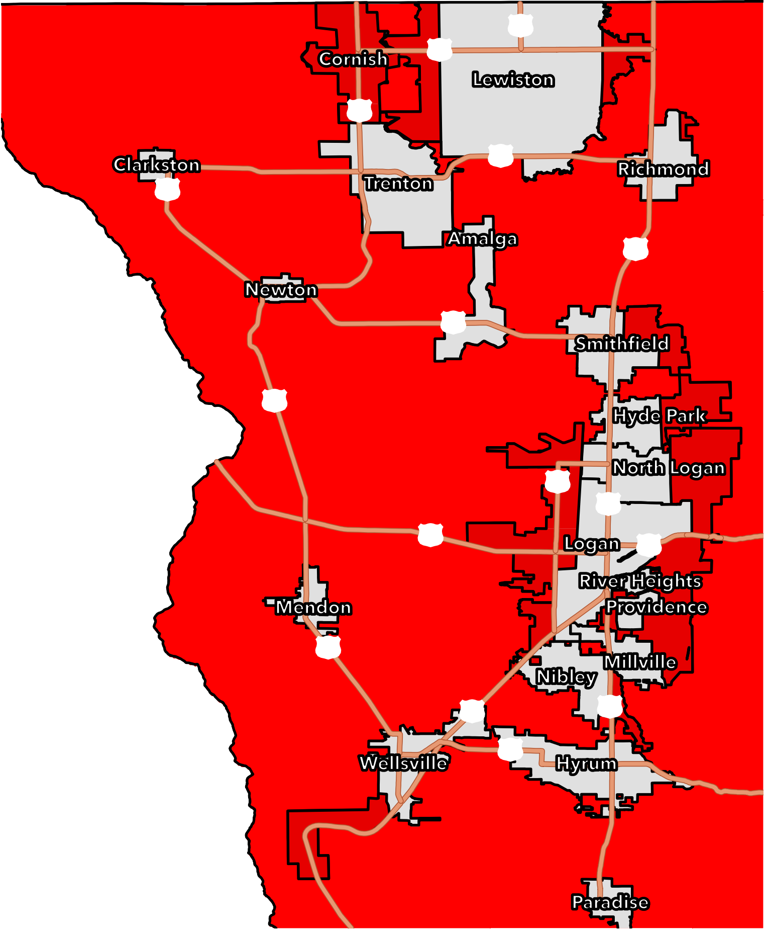
See detailed descriptions of restricted areas on other side.

