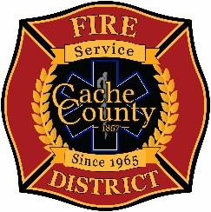
CACHE COUNTY FIRE DISTRICT
BOARD OF TRUSTEES
Kathryn Beus – Board Chair George Daines – Trustee
David Erickson – Trustee Steve Miller – Trustee
Lyndsay Peterson – Trustee Aaron Rudie – Trustee
Larry Jacobsen - Trustee

BOARD OF TRUSTEES MAYORS WORKSHOP MEETING MINUTES
May 7, 2026
4:00pm
The Cache County Fire District Board will meet Thursday, May 7, 2026, commencing at 4:00 p.m. in the Cache County Council Chambers, 179 North Main Logan, Utah 84321.
- CALL TO ORDER:
- WORKSHOP DISCUSSION
-Executive Daines presented his voucher proposal, the proposal aims to ensure fairness by redistributing funds based on service needs and taxable values.
Unfortunately there was technical difficulties, what was recorded will be posted on https://cachecounty.gov/fire/firemeetings.html
- ADJOURN

In compliance with the Americans with Disabilities Act, individuals needing special accommodations (including auxiliary communicative aids and services) during this meeting should notify Janeen Allen, at 755-1850 at least three working days prior to the meeting.

